

E-COMMERCE AUTOMATION
PROJECT USING
AUTOMATION ANYWHERE

E-COMMERCE AUTOMATION:
As we see in our daily life prices of the products in online shopping sites varies from day to day. If we want to purchase a single product. It is easy to search for the price of that single product every day and whenever we like the price we can buy it. But, if we want to buy 20 items. Just imagine how much time it would take to search for each and every product and note down the price. And this should be done once daily. This will lead to a lot of waste of time. Since it is the same process to be done everyday. We can automate this by creating a bot.
The bot itself fetches the list of items to be bought online and it will search for each product and stores the product name, price and the name of the website in which it is available. And the whole will be sent to the mail of the user. Whenever user wants to check the price of the product in different sites. He/She can just run the bot and get the list of result to their email id. This process automation will save a lot of time for the users who shop online. And the users can get the results in just one click.

Platform: (Automation Anywhere)
To build this bot, I have used Automation Anywhere (Community edition). The best part of the Automation Anywhere platform is the ease of use.
This tool can be used to automate small and large scale [processes] depending upon the needs.
This tool has the capability to accommodate every technology and increasing the product functionalities day by day.
The implementation and adoption of a product is highly critical for an organization. The highly rated Bot Creator user interface is easily adoptable across various departments. Without being tech-savvy, a non-developer can learn, create, and run bots with ease.
AA has highly encrypted password locker room to securely store log-in credentials, where passwords can be stored and accessed, which eliminates the security concerns of clients.

Working of the bot:
At first the bot opens the shopping list excel sheet(Session 1) in which the list of items to be bought online. It will read the first column and store it in a list. Now it will open another excel sheet(Session 2) in which the output is stored. Now on excel sheet(Session 2) go to the cell A1.
Now the first loop(loop1) is for each item in the list. This each item will be stored in “item” variable. The bot will now launch the google shopping website and search for the “item”. Now number of results are visible on the webpage.
Bot will now run a loop(loop2) for 10 times. In this loop the current number of iteration is stored in the variable”i”. i’s data type is number. Bot will change the data datatype of “i” to string and save it in variable “i_str”. (using this “i_str” as an iterating variable bot changes the DOMX path and captures the name, price and name of the website in which the product is available)
Now the bot reads the name of the product and writes in the current cell of excel sheet(Session 2). Now the active cell will be shifted to one cell to the right of the current cell. Bot will now read the price of the product and writes in the current cell of excel sheet(Session 2). Now the active cell will be shifted to one cell to the right of the current cell. Bot will now read the name of the website in which item is present and writes in the current cell of excel sheet(Session 2). Now the bot will move the active cell to beginning of the row of the current cell and again move it to one cell below of the current cell. Here the loop2 ends.
Now the bot will move the current cell to one cell below. Here loop1 ends.
Bot will now save the excel sheet(Session 2) and sends an email with the attachment as excel sheet(Session 2). This excel sheet contains the name of the product, Price of the product and the name of website in which the product is present.

Process diagram:

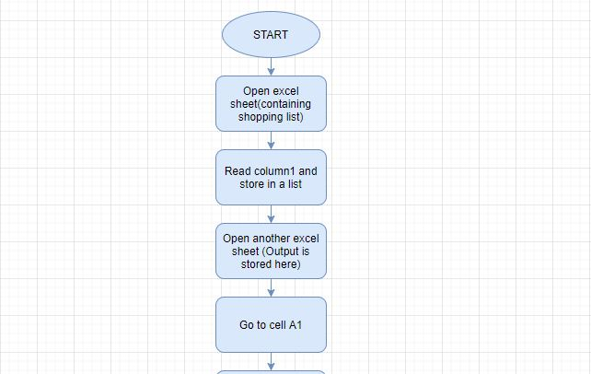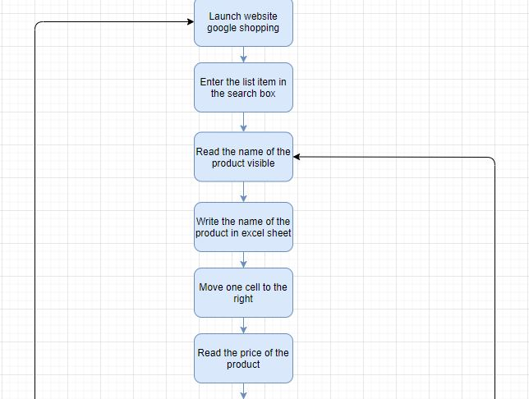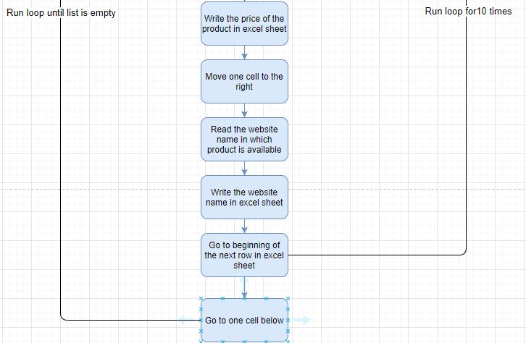

Usecase(algorithm):
- Excel: Action: Open shopping list excel sheet
- Excel: Action: Read first column and save it in a list
- Excel: Action: Open output excel sheet
- Excel: Action: Go to cell A1(in output excel sheet)
- Browser: Action: Launch google shopping website
- Recorder: Action: Capture: Search for the item in the list
- Recorder: Action: Capture: Read the name of the product
- Excel: Action: Set cell: Write the name of the product in the active cell of output excel sheet
- Excel: Action: Go to cell: Go to the right of the current cell
- Recorder: Action: Capture: Read the price of the product
- Excel: Action: Set cell: Write the price of the product in the active cell of output excel sheet
- Excel: Action: Go to cell: Go to the right of the current cell
- Recorder: Action: Capture: Read the name of the website in which product is available
- Excel: Action: Set cell: Write the website name in the active cell of output excel sheet
- Excel: Action: Go to cell: Go to the beginning of the row of the current cell
- Excel: Action: Go to cell: Go to One cell below of the current cell
- Repeat steps from 7 to 16 for 9 times
- Excel: Action: Go to cell: Go to One cell below of the current cell
- Repeat steps from 5 to 18 until the list is empty
- Excel: Action: Save workbook
- Email: Action: Send an email to the user with the attachment of the output excel sheet

Input Excel sheet:
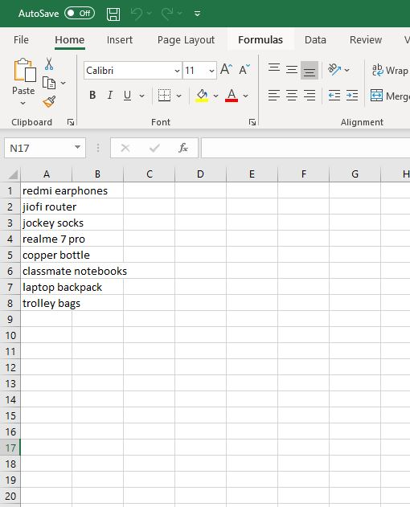

Output excel sheet:
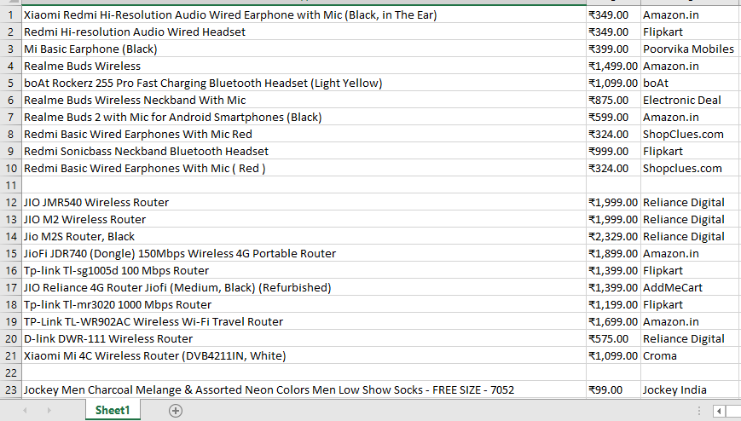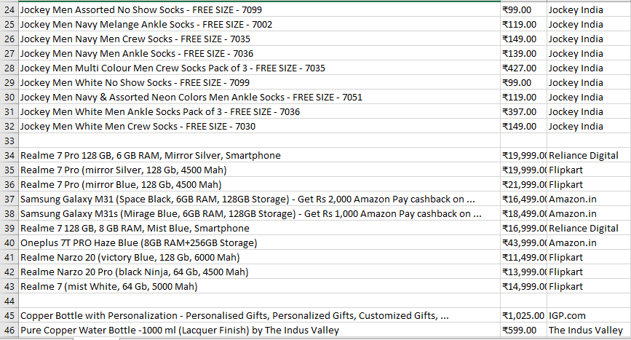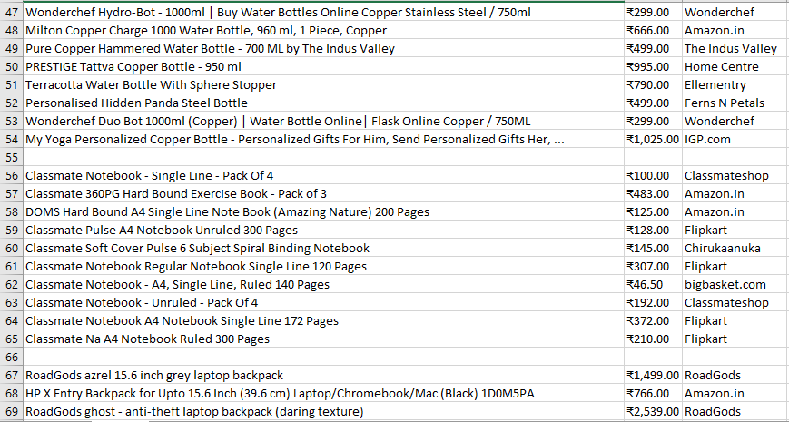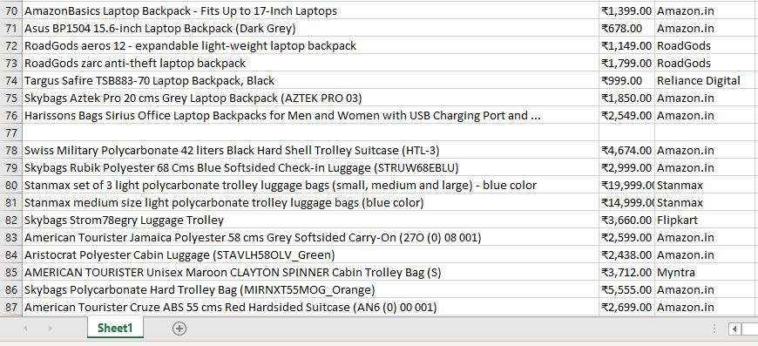

Output email:
